19.3.2 Editors - NLA Editor - Sidebar - Strip tab
Strip Tab 1
Name 1
Mute 1
Active Strip panel 2
Frame Start + End 2
Extrapolation 2
Hold 2
Hold Forward 2
Nothing 2
Blending 2
Replace 2
Combine 2
Add, Subtract, Multiply 3
Blend In + Out 3
Auto Blend In/Out 3
Playback 3
Reversed 3
Cyclic Strip Time 3
Animated Influence 3
Influence 3
Animate Property 3
Animated Strip Time 4
Influence 4
Animate Property 4
Action Clip panel 4
Action 4
Frame Start / End 4
Sync Length 4
Now 4
Playback Scale 4
Repeat 4

Strip Tab
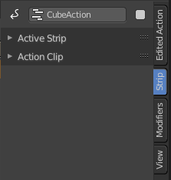
The settings for the currently selected action strip. You need to have a action strip selected to show this tab.

Name
The name of the currently selected action strip.
To rename the strip click into the edit field, change the name and press enter.

Mute
Disable the action strip.

Active Strip panel

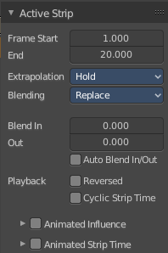

Frame Start + End
The start and end position of the strip.

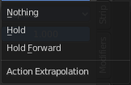
Extrapolation
Action to take for gaps past the strip extents.

Hold
Affects both sides of the strip. This should only be set on the very first strip.

Hold Forward
Affects the region after the clip, only. This can be set on any strip.

Nothing
Affects only the region of the strip itself. This can be set on any strip.

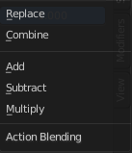
Blending
Affects how the property values directly produced by the strip are combined with the result of evaluating the stack below. The bottom-most strip is blended on top of the default values of the properties.

Replace
The top strip is linearly blended in with the accumulated result according to influence, completely overwriting it if influence is set to 100%.

Combine
Depending on the type of each property, one of the following methods is automatically chosen:
Axis/Angle Rotation
result=previous+value*influence
This results in averaging the axis and adding the amount of rotation.
Quaternion Rotation
Quaternion math is applied to all four channels of the property at once:
result=previous×valueinfluence
Proportional (Scale)
result=previous*(value/default)influence
Others
result=previous+(value-default)*influence
This allows layering actions that can also be used as a standalone. Properties keyframed at their default values remain at default.

Add, Subtract, Multiply
The result of the strip is multiplied, subtracted, or added to the accumulated results, and then blended in according to influence.
result=mix(previous,previous(+-*)value,influence)

Blend In + Out
Number of frames to fade in or out the action strip.

Auto Blend In/Out
Number of frames for blending in and out is automatically calculated from overlapping strips.

Playback

Reversed
The action strip is played in reversed order. This just works when timing is determined automatic.

Cyclic Strip Time
Cycle the action strip.

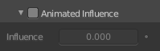
Animated Influence
Control the influence settings by an F-Curve instead of automatically determined. The F-Curve can be edited in the Graph Editor.

Influence
The influence value.

Animate Property
Set or remove a keyframe at current position.

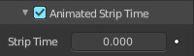
Animated Strip Time
Control the Strip time settings by an F-Curve instead of automatically determined. The F-Curve can be edited in the Graph Editor.

Influence
The influence value.

Animate Property
Set or remove a keyframe at current position.

Action Clip panel
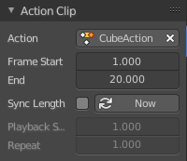
This represents the ‘object data’ of the strip. Much like the transform values of an object.

Action
The action that is referenced in the strip. This can be changed to replace the current strip’s value with another Action in the scene.

Frame Start / End
The start and end frame values of the strip.

Note. To loop the animation you might need to reduce the End Frame by one frame to have a loopable animation.

Note. If you select values that are above or below the actual keyframe count of the Action, then the F-curve Extrapolation will be applied.

Sync Length
Set the Start and End Frames to the first and last keyframed frames of the Action.

Now
Causes the Start and End Frames, above, to be reset to the first and last keyframed frames of the Action.

Playback Scale
Stretches the strip.

Repeat
Repeats the strip by the chosen value. With a value of 1 the strip plays once.

